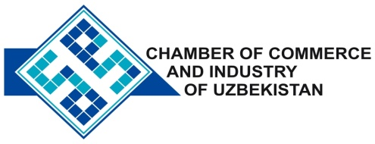

**Commercial offer of Uzbek Products to Foreign Buyer**

Dear Sirs, KP - 007

We are pleased to offer you products of the company "Ammafos Maxam"

**Information about the company:**

Ltd "Ammafos Maxam" specializes in the production of mineral fertilizers and inorganic substances

**List of products:**

Ammafos

Suprefos - N N: P: Mg: Ca: S

phosphate ammoniyasulfat

Technical sodium phosphate

**Terms of delivery:** FCATashkent

If you are interested, we are happy to provide additional information in accordance with your request.

E-mail: [export@chamber.uz](mailto:export@chamber.uz)

Website: [www.chamber.uz](http://www.chamber.uz)

Export Promotion Department.

Chamber of Commerce of the Republic of Uzbekistan.